CSI3344 Principle of Distributed Systems

**Workshop 06**

1. Refer to the following figure (Figure 1):

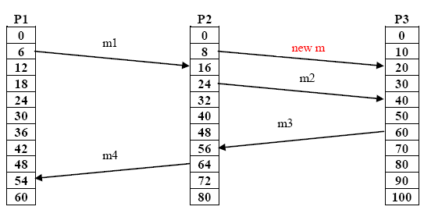

**Figure 1. Three processes, each with its own clock, and four messages between processes. The clocks run at different rates.**

Add a new message to the figure that is concurrent with message *m1*, that is, it happens neither before *m1* nor after *m1*.

Add a new message to the figure that is after *m1*but before *m4.*

1. The following diagram (Figure 2) shows that two updates on the same bank account at two replicated databases in different places take place at the same physical time, leaving it in an inconsistent state. Suppose that the account balance is $5000 before the updates take place. One update is to deposit $2000 to the account. The other update is to increase the interest by 1%.

The two copies of the same account must have the same balance after the completion of the two updates, no matter whichever commits first.

Describe how to use Vector Timestamps to keep this replicated database system consistent in the given conditions.

[*Hints: Refer to Chapter 6 in the Text. Two cases to be considered.*]

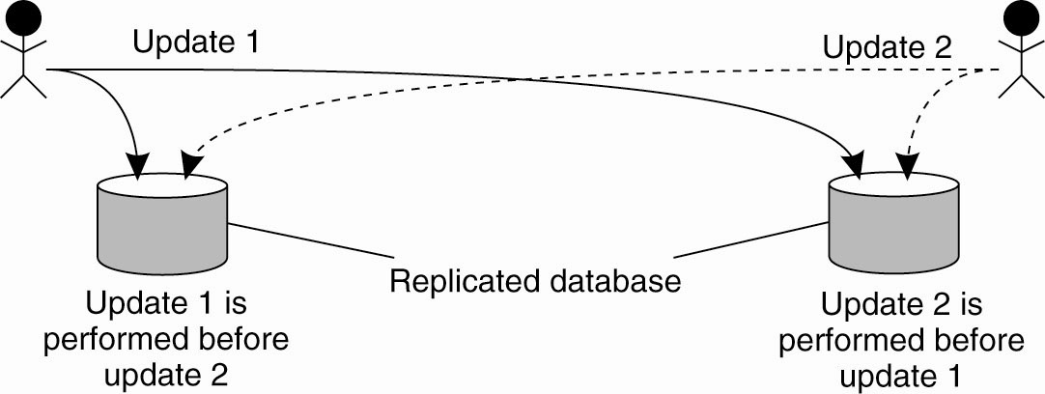

**Figure 2: Updating a replicated database and leaving it in an inconsistent state**

**END OF THE WORKSHOP**